**Lesson06 Angular nested form groups**

**Notes:-**

**1-In addition to full Name and email, we want to add the following 3 fields to "Create Employee" form.   
A-Skill Name B-Experience in Years C-Proficiency**

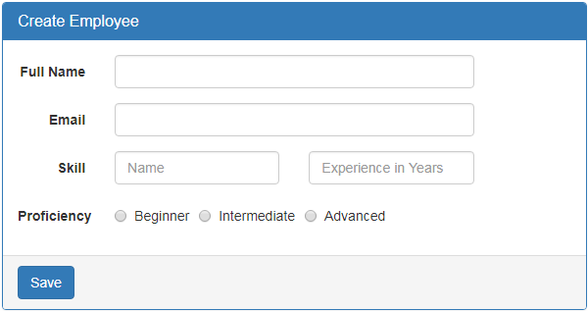

**2-What we want to be able to ultimately do is add multiple skills dynamically at run time, by clicking "Add a new skill" button.**

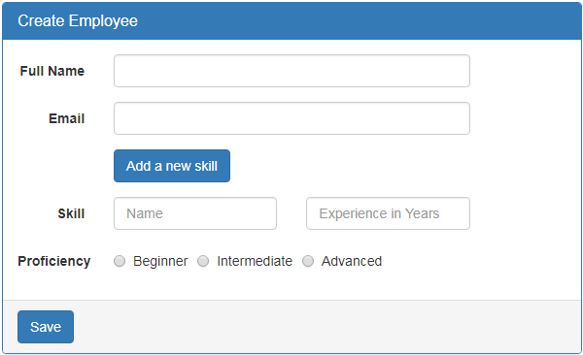

When the button is clicked, we want to dynamically add another set of skill related fields

1-Skill Name

2-Experience in Years and

3-Proficiency

Another additional requirement is to keep "Add a new skill" button disabled, until all the skill related fields are properly filled and valid.

**Section 01(Apply Nested Form Group inside another Form Group)**

**1-in the ts file we apply the following code**

**import { Component, OnInit } from '@angular/core';**

**// Import FormGroup and FormControl classes**

**import { FormGroup, FormControl } from '@angular/forms';**

**import { ReactiveFormsModule } from '@angular/forms';**

**@Component({**

**selector: 'app-employee-react-comp',**

**templateUrl: './employee-react-comp.component.html',**

**styleUrls: ['./employee-react-comp.component.css']})**

**export class EmployeeReactCompComponent implements OnInit {**

**empForm:FormGroup;**

**constructor() { }**

**ngOnInit() {**

**this.empForm = new FormGroup({**

**FullName: new FormControl(),**

**Email: new FormControl(),**

**// Create inner form group skills inside outer form group**

**skills: new FormGroup({**

**skillName: new FormControl(),**

**experienceInYears: new FormControl(),**

**proficiency: new FormControl()})**

**});}**

**onSubmit(): void {**

**console.log(this.empForm.value);}}**

**2-in the html page we inject <div formGroup=””></div>**

<form class="form-horizontal" [formGroup]="empForm" (ngSubmit)="onSubmit()" >

<div class="panel panel-primary">

<div class="panel-heading">

<h3 class="panel-title">Create Employee</h3></div>

<div class="panel-body">

<div class="form-group">

<label class="col-sm-2 control-label" for="fullName">Full Name</label>

<div class="col-sm-8">

<input id="fullName" type="text" class="form-control" formControlName="FullName" /></div></div>

<div class="form-group">

<label class="col-sm-2 control-label" for="email">Email</label>

<div class="col-sm-8">

<input id="email" type="text" class="form-control" formControlName="Email"/></div></div>

//we inject the <div formGroupName=”skills” inside the <form> tag

<div formGroupName="skills">

<div class="form-group">

<label class="col-sm-2 control-label" for="skillName">Skill</label>

<div class="col-sm-4">

<input type="text" class="form-control" id="skillName" placeholder="Name" formControlName="skillName">

</div>

<div class="col-sm-4">

<input type="text" placeholder="Experience in Years" class="form-control" formControlName="experienceInYears">

</div>

</div>

<div class="form-group">

<label class="col-md-2 control-label">Proficiency</label>

<div class="col-md-8">

<label class="radio-inline">

<input id="proficiency" type="radio" value="beginner" formControlName="proficiency">Beginner

</label>

<label class="radio-inline">

<input id="proficiency" type="radio" value="intermediate" formControlName="proficiency">Intermediate

</label>

<label class="radio-inline">

<input id="proficiency" type="radio" value="advanced" formControlName="proficiency">Advanced

</label></div></div></div>

</div>

<div class="panel-footer">

<button class="btn btn-primary" type="submit">Save</button></div></div>

</form>

<table><tr>

<th style="padding: 10px">FormGroup</th>

<th style="padding: 10px">FormControl (fullName)</th></tr>

<tr><td style="padding: 10px">

Form Touched : {{empForm.touched}}<br />

Dirty : {{empForm.dirty}}<br />

valid : {{empForm.valid}}<br />

FormValues : {{empForm.value | json}}

</td>

<td style="padding: 10px">

Form Touched : {{empForm.controls.FullName.touched}}<br/>

Dirty : {{empForm.controls.FullName.dirty}}<br/>

valid : {{empForm.controls.FullName.valid}}<br/>

Form Touched : {{empForm.controls.FullName.value}} {{empForm.get("FullName").value}}

</td>

</tr>

</table>